**Assignment 4**

**Data Science Masters**

**1.1 Write a Python Program(with class concepts) to find the area of the triangle using the below**

**formula. area = (s*(s-a)*(s-b)*(s-c)) ** 0.5**

**Function to take the length of the sides of triangle from user should be defined in the parent**

**class and function to calculate the area should be defined in subclass.**

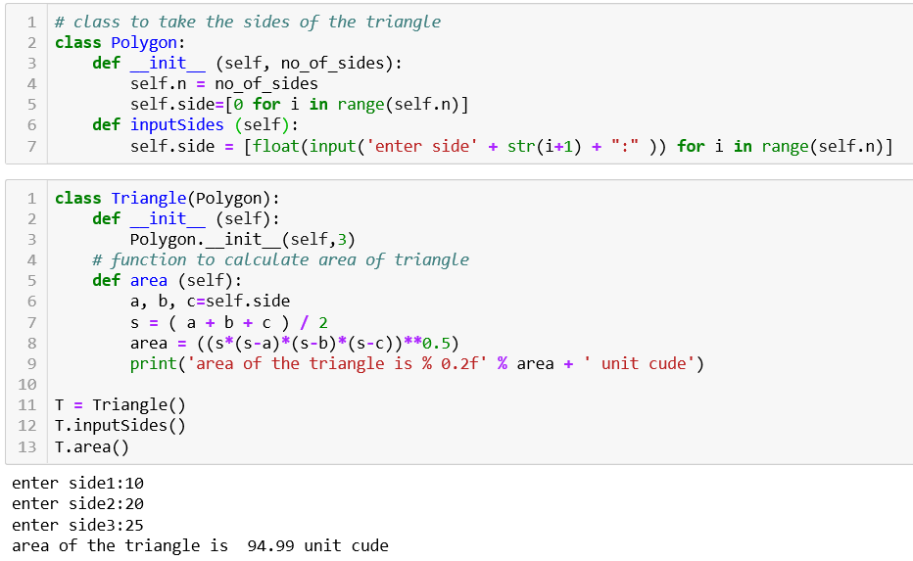

Cont…………

**1.2 Write a function filter_long_words() that takes a list of words and an integer n and returns**

**the list of words that are longer than n.**

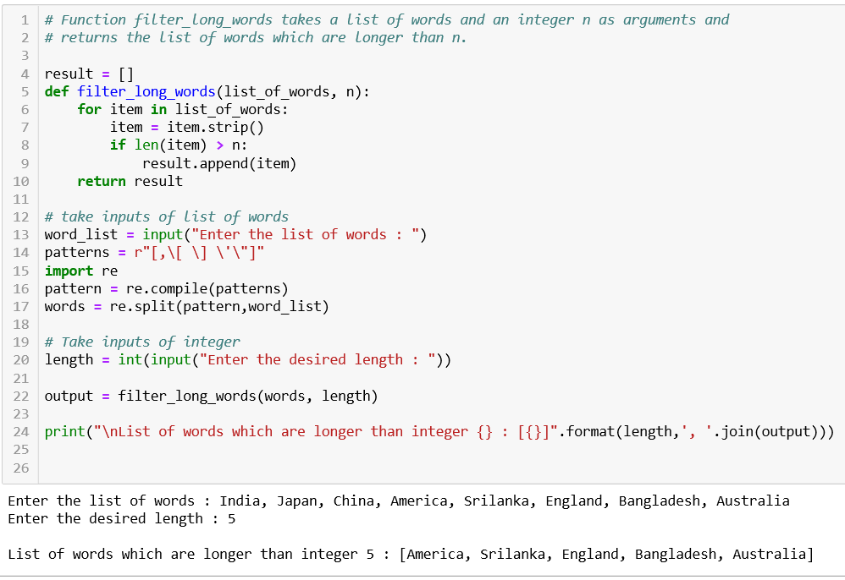

Cont……..

**2.1 Write a Python program using function concept that maps list of words into a list of integers**

**representing the lengths of the corresponding words .**

**Hint: If a list [ ab,cde,erty] is passed on to the python function output should come as [2,3,4]**

**Here 2,3 and 4 are the lengths of the words in the list.**

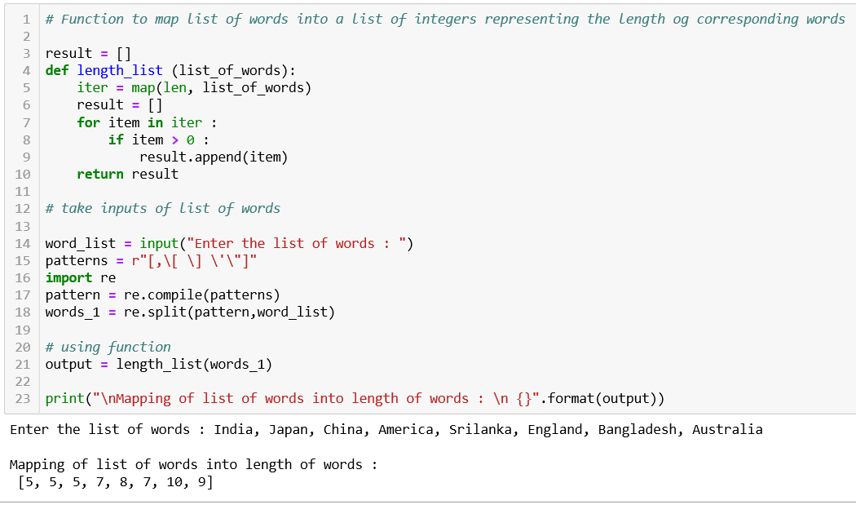

**Cont…….**

**2.2 Write a Python function which takes a character (i.e. a string of length 1) and returns True if**

**it is a vowel, False otherwise.**

